**Abstract**

Written after paper is developed

**Intro/background context**

The heavy usage of fertilizer application in the agriculture industry is largely looked at as a major non-point source contributor to algal blooms occurring in Lake Erie. Abundant application of fertilizer causes eutrophication. This is an excessive richness in a lake or body of water, frequently due to runoff from the land, which causes a dense growth of plant life. Due to the high density of plant life, large amounts of oxygen are taken from the water causing hypoxia therefore affecting other aquatic life within the ecosystem. The two major elements contributing to eutrophication are nitrogen and phosphorus. Note that the limiting nutrient in freshwater systems is phosphorus and on the contrary nitrogen is the limiting nutrient in saltwater. The primary focus of this paper is to understand and quantify relative values of phosphorus usage and its potential contribution to Lake Erie. However due to Ohio’s unique location these nutrients have an influence on both water systems. Depending on the area within the state nutrients may drain to a watershed that leads to either Lake Erie or the Ohio River which drains down to the Mississippi River and into the ocean. Therefore, applicators should be wary of both adverse effects.

As mentioned above current application of fertilizer usage from conventional farming practices play a large part in non-point source water pollution. However, these traditional farming practices are typically done within a short season and with a few applications. Another aspect for consideration and where there is little public awareness is the horticulture industry. Due to the nature of this industry fertilizer consumption is used on a more frequent basis throughout the year to maximize plant growth and yield. Because usage seems to be so small there is little research for possible contribution. But due to horticulture applications being done all throughout the year and in great volume due to high density there is still an exponential amount to be accounted for. The question is due to the high consumption in horticulture just how much does this industry contribute to current phosphorus and nitrogen levels?

lake erie article ? add quote?

This paper will explore both greenhouse (glass covered) and container nursery area usage. That being said this still leaves room for the idea of other open field practices besides container nurseries to be explored.

**Approach**

We found a total area of both greenhouses (area underneath glass) and container nurseries (open field) through the 2017 USDA NASS Census of Agriculture where all county data are reported in Ohio. In order to figure which counties would be applicable to this study, counties were selected via ODNR data. ODNR resources were used to split watershed and drainage areas of the Ohio River in contrast to Lake Erie. (<http://water.ohiodnr.gov/maps/watershed-drainage-basin-maps> ). This delineates the areas by county. Once counties were accounted for to be included a square footage of both greenhouses (under glass ceiling) and container nurseries (open field) could be calculated. Of the 88 counties in Ohio 34 of them fall within Lake Erie’s drainage divide. Once this is done a square footage value could then be applied to the appropriate scenario. Due to greenhouses and container nurseries being different practices a nutrient discharge value needs to be expressed with a relative area for both scenarios. By conducting a small-scale concentration output respectively to each area, this value can then be multiplied by the total area. Therefore, configuring an appropriate magnitude for each scenario. Once the total nutrient value is derived from the full scale it can then be compared with Ohio EPA Nutrient Mass Balance Study to figure a percentage of nutrient contribution over total annual load reported in this study (?). The following watersheds are included within Lake Erie’s drainage area: Maumee, Portage, Sandusky, Frontal Lake Erie, Vermillion, and Cuyahoga.

**Greenhouse**

Among limited information regarding nutrient discharge from greenhouses, Audiru et al. (2015) reports “*Quantifying Water and Nutrient Losses with Hose Irrigation*” (<https://hrijournal.org/doi/pdf/10.24266/0738-2898-33.1.29>). We found that this report can be usable to find nutrient discharge in a worst-case scenario, specifically when hose irrigation was used with water soluble fertilizer (WSF) causing nutrients leached and missed from hose irrigation inside a greenhouse. Specific computational processes are summarized below.

* By using data shown below (Table 1) and experimental conditions reported by Audiru et al. (2015), we found an average of the amount of nutrient solution being leached and missed on a liter per day basis.
* To obtain these values, Audiru et al. (2015) evaluated the watering practice(noted as WSF) by measuring three separate sampling times. We took the average of these three reported as the volume to discharge solution per day. The box used for discharge collection consisted of a pan covering 2.9ft by 1.4ft area (4.06 ft2).
* Now, WSF water leached equals 4.8 L/d, and WSF missed equals 7.7 L/d.
* Assuming that greenhouses would apply fertilizer three times a week and multiplying this by the area gives a total area for greenhouse estimated earlier.
* Therefore, taking the area of the box (2.9ft by 1.4ft) and multiplying by the number of weekly application (3), this gives the value ${12.18ft}^{2}$.
* Next using the water usage of 4.8L/d and 7.7L/d then dividing by ${12.18ft}^{2}$, this gives the values of .394L/d/ ${ft}^{2}$ being leached and .632L/d/ ${ft}^{2}$ missed of water. By dividing volume by area thus giving a volume by area of water.

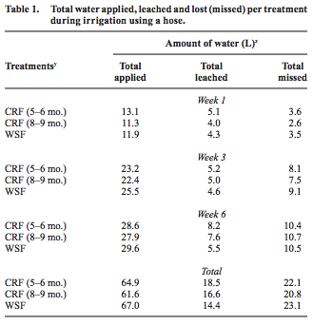

(Dr. Pasian)

* The phosphorus concentration of nutrient solutions leachates and/or missed between pots were reported through three sampling weeks of analysis. We used the average concentrations reported for these three weeks for our analyses.
* WSF concentration of P in leachates equals 21.3mg/L and WSF missed equals 32.57mg/L per treatment. Taking the leached (.394L/d/ ${ft}^{2}$) and missed (.632) values of water and multiplying by the greenhouse square footage 24,680,688 ${ft}^{2}$. This gives the total leached and missed water over the total area.
* Next by multiplying the new leached values of water 9,726,379.51L/d and 15,602,733.79L/d by the concentration of 21.3mg/L leached and 32.57mg/L missed gives a total concentration of 207,171,833.8mg/d leached and 508,129,030.53mg/d missed. These values then need to be converted to kg/d, ultimately totaling to P 207.17kg/d leached and 508.13kg/d missed. Next adding the two values gives a total of 715.30 kg/d.
* According to the Nutrient Mass Balance Study (pg.11) based off the area with an assumed adsorption rate of 60% equals 429.18kg/d. Taking this final value and multiplying by 300 for the assumed days of irrigation within a year equals 128,754.16kg/yr.
* Comparing this value to the year 2017, 4,492,000 kg/yr, and five-year average, 3,483,000kg/yr. Greenhouse contribution alone accounts for approximately 2.87-3.70% of phosphorus discharge.

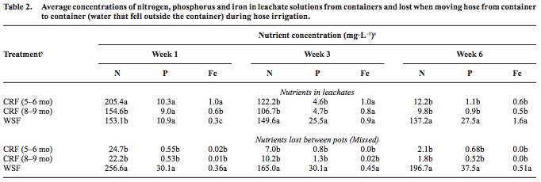

(Dr.Pasian)

**Container Nursery**

Similar to the greenhouse approach open field calculations were conducted in a similar way. A research article called the “*Water quality characterization of storm and irrigation runoff from a container nursery*” was used to help find the overall estimate of phosphorus discharge from nurseries. “The objectives of this study were to characterize irrigation and storm runoff quantity and quality at a Mid-Atlantic nursery site. As well as to estimate average annual loading of nutrients, of those including phosphorus, from a container nursery production area for use in water quality planning.” (Reference). This research article estimates that container nurseries produce up to 12kg/ha/yr of phosphorus discharge respectively. By using this information and the open field area calculated from the USDA, 1860.73ha, a total output of phosphorus can be figured, 24,003.4 kg/yr. Of this value, a nursery environmental scientist estimates that 60% of nurseries use retention ponds, this helps reduce runoff by catching the nutrients. To stay in the scope of container nurseries, a county educator estimates that of the open field area approximately 40% are within container nursery guidelines. Thus, reducing the final value of 24,003.4kg/yr to 5,760.82 kg/yr. Again, similar to the greenhouse section comparing this value to 2017, 4,492,000 kg/yr, and the five-year average, 3,483,000kg/yr. Container nurseries contribute approximately .13-.17% of phosphorus discharge.

**Results, Discussion, & (BMP’s)**

Maumee, Portage, Sandusky, Frontal Lake Erie, Vermillion, and Cuyahoga accounted for a total of 4,492 mta of P in 2017, and for a five-year average of 3,484 mta. This equates to 4,492,000 kg/yr and 3,483,000 kg/yr of phosphorus discharge.

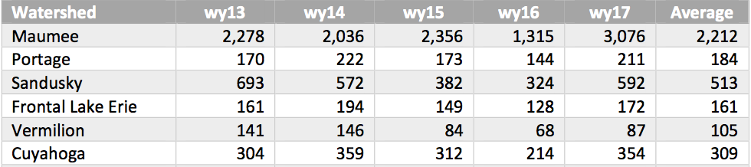

(EPA Mass Balance Study)

BMP’s

Maryland – strict regulations

Each operation is different and therefore practices should be circumstantial to the given situation, based on size of operation, plants and irrigation methods

Greenhouse

Open Field

Canadian guidelines

Circulatory systems

Catch basin/ retention pond

USDA – open field

Don’t apply on frozen ground

Before rain

Used fixed adsorption rate

Compared value to overall p discharge for percentage

Container nurseries

Leave open ended

Generate discussion/speculation

Leave/lead to ask questions

Does it make sense??

**References**

**Contributors**

**-**

Needed to find concentration by using the study